Low Level Design (LLD)

Analyze International Debt Statistics

## Revision Number - 1.0

**Last Date of Revision 10/08/2022**

**Sharat Achanta**

**Umesh Pawar**

**Document Control**

|  |  |  |  |
| --- | --- | --- | --- |
| **Date** | **Version** | **Description** | **Author** |
| 19/09/2022 | 1.0 | Final Revision | Sharat Achanta  Umesh Pawar |
|  |  |  |  |
|  |  |  |  |

## Why this Low-Level Design Document?

The purpose of this document is to present a detailed description of the Analyze International Debt Statistics analysis technique. It will explain the necessary steps which have to be followed before any analysis can begin. LLD describes the class diagrams with the methods and relations between classes and programs specs. It describes the modules so that the programmer can directly code the program from the document. This document is intended for both the stakeholders and the developers of the system and will be proposed to the higher management for its approval.

The LLD will be focusing on the below objectives:

* Problem Understanding.
* Data Acquisition.
* Data Pre-Processing and Exploratory Analysis
* Development of models
* Auditing accuracy and retrain if require
* Finalizing the model
* Dashboard report for important activities.

**Scope :**

The LLD documentation presents the detailed structure of the International Debt Statistics analytics for each of its individual components. The goal of LLD is to give the internal logical design of the actual program code. Low-level design is created based on the high-level design. The LLD documentation contains the complete description of the model used along with the comparisons of the proposed model/library compared with a baseline(existing) model against a set of metrics.

**Project Introduction**

It's not that we humans only take debts to manage our necessities. A country may also take debt to manage its economy. For example, infrastructure spending is one costly ingredient required for a country's citizens to lead comfortable lives.

you are going to analyze international debt data collected by The World Bank. The dataset contains information about the amount of debt (in USD) owed by developing countries across several categories.

The given dataset contains debt, indicators and year-wise data of world bank.

**Constraints**

Our analysis is done based on dataset provided for different 123 countries and 563 indicators. The analysis is done debt and year wise.

**Risks**

Document specific risks that have been identified or that should be considered.

**Out of Scope**

Delineate specific activities, capabilities, and items that are out of scope for the project.

1. **Technical specifications :**

**Dataset :**

The Dataset is taken from iNeuron’s provided dataset-

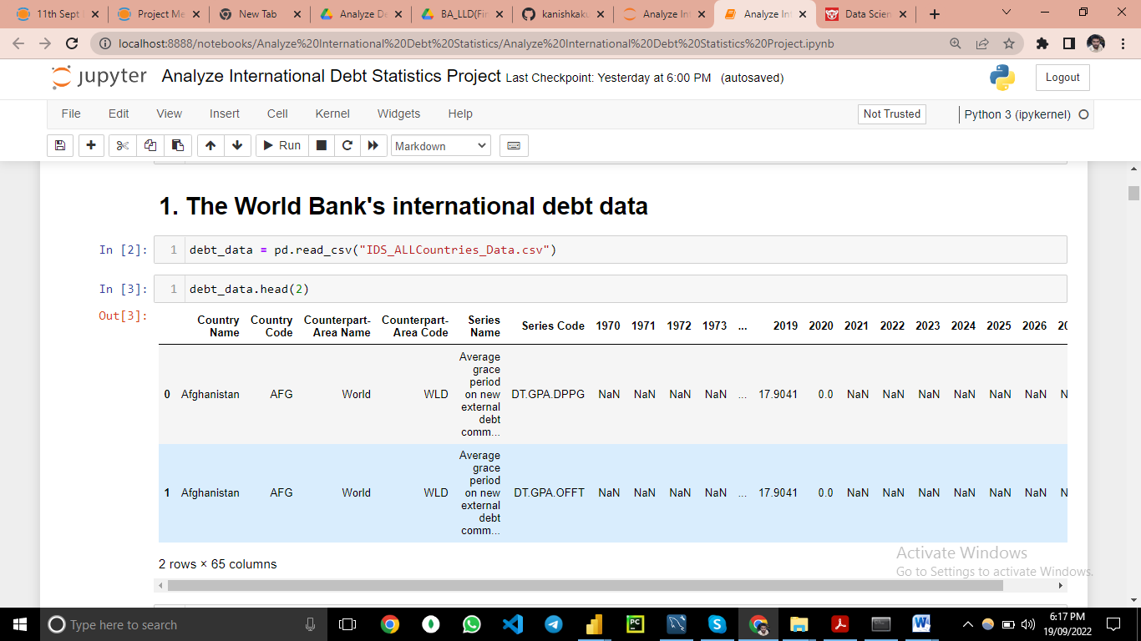

Figure 1: International debt Dataset

The dataset consists of 77389 individual data. There are 65 columns in the dataset which are described below.

1. **Country Name**–There are total 138 country’s name. Some of them are
2. Afghanistan
3. Bhutan
4. Egypt
5. India
6. From 1st to 6th Columns country name, country code,

| Counterpart-Area Name | **Counterpart-Area Code** | **Series Name** | **Series Code** |
| --- | --- | --- | --- |

1. is mentioned and then rest in 59 columns from 1970 to 2028 historic data of debt are mentioned.

# Problem Statement :

It's not that we humans only take debts to manage our necessities. A country may also take debt to manage its economy. For example, infrastructure spending is one costly ingredient required for a country's citizens to lead comfortable lives. The World Bank is the organization that provides debt to countries.

In this project, you are going to analyze international debt data collected by The World Bank. The dataset contains information about the amount of debt (in USD) owed by developing countries across several categories. You are going to find the answers to questions like:

• What is the total amount of debt that is owed by the countries listed in the dataset?

• Which country owns the maximum amount of debt and what does that amount look like?

• What is the average amount of debt owed by countries across different debt indicators?

# Architecture



Real World

Exploratory Data Analysis (EDA)

Modelling

Deployment

Data Cleaning

Data Pre- Processing

Raw Data Collection

Reporting

* 1. **Architecture Description**
     1. **Raw Data Collection-** The Dataset was taken from iNeuron provided Project Description Document.

[**https://datacatalog.worldbank.org/dataset/international-debt-statistics**](https://datacatalog.worldbank.org/dataset/international-debt-statistics)

### Data Pre-Processing :

Before building any model, it is crucial to perform data pre-processing to feed the correct data to the model to learn and predict. Model performance depends on the quality of data to the model to train.

This Process includes-

* + - 1. Handling Null/MissingValues

### Data Cleaning :

Data cleaning is the process of fixing or removing incorrect, corrupted, incorrectly formatted, duplicate, or incomplete data within a dataset.

* + - 1. Remove duplicate or irrelevant observations
      2. Filter unwanted outliers
      3. Renaming required attributes

### Exploratory Data Analysis (EDA)

Exploratory Data Analysis refers to the critical process of performing initial investigations on data to discover patterns, spot anomalies, test hypothesis

and to check assumptions with the help of summary statistics and graphical representations.

### Reporting

Reporting is a most important and underrated skill of a data analytics field. Because being a Data Analyst you should be good in easy in report because your model will be used by many stakeholders who are not from technical background.

* + - 1. High Level Design Document(HLD)
      2. Low Level Design Document(LLD)
      3. Architecture
      4. Wireframe
      5. Detailed Project Report
      6. Power Point Presentation

### Modelling

Data Modelling is the process of analysing the data objects and their relationship to the other objects. It is used to analyse the data requirements that are required for the business processes. The data models are created for the data to be stored in a database. The Data Model's main focus is on what data is needed and how we have to organize data rather than what operations we have to perform.

### Deployment

I have created power BI dashboard .

